**Floor Cleaning Robot with Mobile-App or Autonomous**

**Mini Project**

**By**

**Vatsal shah**

**Roll No: IU1241090055**

Under the Guidance of

**Prof. Abhishek Vaghela**



**Department of Electronics & Communication Engineering**

**Indus Institute of Technology and Engineering**

**Indus University, Ahmedabad**

**Gujarat, India**

**May 2015**



**Department of Electronics & Communication Engineering**

**Indus University**

**CERTIFICATE**

This is to certify that the Mini project Report entitled “Floor Cleaning Robot with Mobile App or Autonomous” submitted by **Mr. VATSAL SHAH** bearing **Roll No. IU1241090055** in partial fulfilment of the requirements for the award of Bachelor of Technology in Electronics and Communication Engineering during session 2015-2016 at Indus University, Ahmedabad is an authentic work carried out by his under my supervision and guidance.

To the best of my knowledge, the matter embodied in the report has not been submitted to any other University / Institute for the award of any Degree.

**Abhishek Vaghela**

**Place: Associate Professor**

**Date: Dept. of Electronics and Comm. Engineering**

**Indus University**

**Ahmedabad-382115**

**ACKNOWLEDGEMENT**

The satisfaction and euphoria on the successful completion of any task would be incomplete without mentioning the people who made it possible whose constant guidance and encouragement crowned out effort with success.

I would like to express my heartfelt gratitude to my esteemed supervisor, Prof. Abhishek Vaghelafor his technical guidance, valuable suggestions, and encouragement throughout the experimental and theoretical study and in this project. It has been my honour to work under his guidance, whose expertise and discernment were keys in the completion of this project.

I am grateful to the Dept. of Electronics & Communication Engineering, for giving me the opportunity to execute this project, which is an integral part of the curriculum in B.Tech programme at the Indus University, Ahmedabad.

Many thanks to Satvik KVPS and my friends who are directly or indirectly helped me in my project work for their generous contribution towards enriching the quality of the work.

This acknowledgement would not be complete without expressing my sincere gratitude to my parents and sister for their love, patience, encouragement, and understanding which are the source of my motivation and inspiration throughout my work.

**Vatsal Shah**

**Date: Roll No: IU1241090055**

**Place: Dept. of ECE**

**IITE, Ahmedabad**

**ABSTRACT**

Households of today are becoming smarter and more automated. Home automation delivers convenience and creates more time for people. Domestic robots are entering the homes and people’s daily lives, but it is yet a relatively new and immature market. However, a growth is predicted and the adoption of domestic robots is evolving. Several robotic vacuum cleaners are available on the market but only few ones implement wet cleaning of floors. The purpose of this project is to design and implement a Vacuum Robot Autonomus and Mannual via Phone Applcation. Vacuum Cleaner Robot is designed to make cleaning process become easier rather than by using manual vacuum. The main objective of this project is to design and implement a vacuum robot prototype by using Arduino Mega, Arduino Sheild, LDR Sensor, Real Time Clock, Motor Shield L293D, Ultrasonic Sensor, IR Sensor and to achieve the goal of this project. Vacuum Robot will have several criteria that are user-friendly.

**TABLE OF CONTENTS**

**Particulars Page No. Page No.**

ABSTRACT 4

TABLE OF CONTENTS 5

LIST OF FIGURES 6

LIST OF TABLES 6

LIST OF ABBREVIATIONS 6

Ch-1 Introduction 8

Ch-2 Design Methodology 10

**2.1 Microcontoller: Arduino Mega 2560 10**

**2.2 Motor Driving IC L239D 11**

**2.3 DC Motor 12**

**2.4 Bluetooth (HC - 06) 12**

**2.5 IR Sensor 12**

**2.6 LDR Sensor 12**

**2.7 Ultrasonic Sensor 12**

**2.8 Real Time Clock 13**

**2.9 Vaccum Cleaning Mechanisam 13**

Ch-3 Application Software 14

Ch-4 Result and Analysis 15

Ch-5 Conclusion 15

References 15

# 

**LIST OF FIGURES**

|  |  |  |
| --- | --- | --- |
| **Figure No.** | **Figure Title** | **Page No.** |
| 2.1 | Block Diagram of system | 8 |
| 2.2 | A pulse width modulated waveform | 8 |
| 2.1.3 | Arduino Uno Front and Back | 9 |
| 2.1.1(A) | Pin configuration of L293D | 9 |
| 2.3 | Behaviours of motor for different input conditions | 9 |
| 3.1 | Screenshot of the Front Panel of our system | 11 |
| 3.2 | Screenshot of block Diagram of the system | 11 |
| 4.1 | Full Development System. | 12 |

# **LIST OF TABLES**

|  |  |  |
| --- | --- | --- |
| **Table No.** | **Table Title** | **Page No.** |
| 2.2 | Behaviours of motor for different input conditions | 9 |
| 4.1 | Operation of components in different modes | 13 |
|  |  |  |

**LIST OF ABBREVIATIONS**

|  |  |
| --- | --- |
| LabVIEW | Laboratory Virtual Instrument Engineering Workbench |
| PC | Personal Computer |
| VI | Virtual Instrument |
| NI | National Instrument |
| I/O | Input/output |
| USB | Universal Serial Bus |
| PWM | Pulse with Modulation |

**Ch-1 Introduction**

The research and development of an autonomous mobile robot and a Mannual Phone Application Control prototype able to vacuum cleaning a room or even an entire house is not a trivial challenge. In order to tackle such a task, so that it could be completed in six weeks (the duration of the course), some simplifications and assumptions were made to the designers initial idea of an “ideal” autonomous/mannual vacuum cleaner. In this way, some functional requirements that would improve the robot performance were not taking into account due either to their inherent complexity or to their mechanical implications.

These robots operate semi- or fully autonomously to perform services useful to the well-being of humans and equipment. With the aim of keeping our robot as simple as possible, while able to perform the initial goals, i.e. an autonomous vacuum cleaner robot able to randomly navigate through a room or a house with the minimum human assistance, the following specifications were found:

* Obstacle avoidance
* Floor detection
* Collision detection
* Battery monitoring
* Fan motor monitoring
* Light Sensing
* Real Time Clock
* System on automatically

These specifications correspond to some of the expected behaviours that will be programmed into the robot. Other behaviours that will increase the overall performance of the robot.

In this section i.e. Chapter 1 we gave a brief introduction about how the vacuum cleaner will operate via a mobile application and automatically to make human life easy. In Chapter 2 we will discuss about the background details about the project which includes about the android platform, connectivity, dc motor, l298D motor shield and Arduino Mega board, Sensors, Vaccum Mechanisam, Dispay, Real Time clock. In Chapter 4 we will disucss about the Application Software part and in chapter 5 result and analysis.

**Ch-2 Design Methodology**

A number of software and hardware implementation techniques were used to design and develop the system. Fig. 1 shows the block diagram of system. We used a 12VDC motor, L293D IC, Different Sensors, Real Time Clock,Vaccum mechanisam and Arduino to develop our system.

The operation of the robotic vacuum is going to be based on retrieving data from an array of inputs that will tell the condition of the floor space around the vacuum. These inputs include sonar, touch sensors, and a digital compass. Each of these parts will be described in further detail further on later in the documentation. The data from these inputs will be fed into the chip(s) which through its software program will decide which direction the vacuum should move by sending the control signals out to the drive motors.

Switch Auto/ Mannual

Vacuum

Ultrasonic

Sensors

IR

Sensors

LDR

Sensors

Battery

& Power

Regulator

Left

Motor

Right

Motor

**MOTOR:**

**CHIP:**

**Autonomous/Mannual Robotic Vacuum Cleaner**

Micro Controller

LCD

Display

Real

Time

Clock

Figure 1. The initial block diagram for the Autonomous/Mannual Robotic Vacuum Cleaner

**Components:**

* 1. ***Microcontoller: Arduino Mega 2560***

The Arduino Mega is a microcontroller board based on the ATmega1280 (datasheet). It has 54 digital input/output pins (of which 14 can be used as PWM outputs), 16 analog inputs, 4 UARTs (hardware serial ports), a 16 MHz crystal oscillator, a USB connection, a power jack, an ICSP header, and a reset button. It contains everything needed to support the microcontroller; simply connect it to a computer with a USB cable or power it with a AC-to-DC adapter or battery to get started.

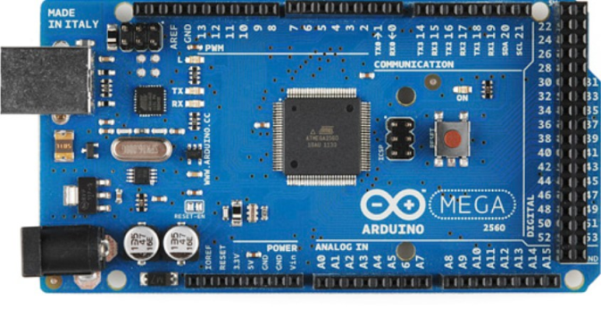

**Figure 2.1: Arduino Mega Front**

* 1. ***Motor Driving IC L239D***

A very easy and safe is to use popular L293D chip. It is a 16- pin chip. The pin configuration of a L293D along with the behaviours of motor for different input conditions is given in fig. 4. The L293D is designed to provide bidirectional drive currents of up to 600-mA at voltages from 4.5 V to 36 V. When an enable input is high, the associated drivers are enabled. Also their outputs are active and in phase with their inputs. When the enable input is low, those drivers are disabled, and their outputs are off and in the high-impedance state. With the proper data inputs, each pair of drivers forms a full-H (or bridge) reversible drive suitable for solenoid or motor applications.

**Table 2.2:Behaviours of motor for different input conditions**

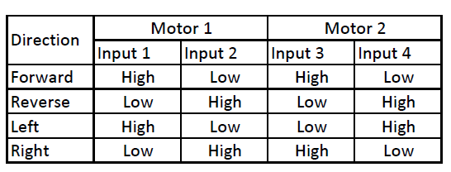

**Figure 2.2.1: (A) Pin configuration of L293D**

The dc motor and L293D IC has been connected according to the fig. 9. The circuit schematic as shown has been designed using Proteus 7.

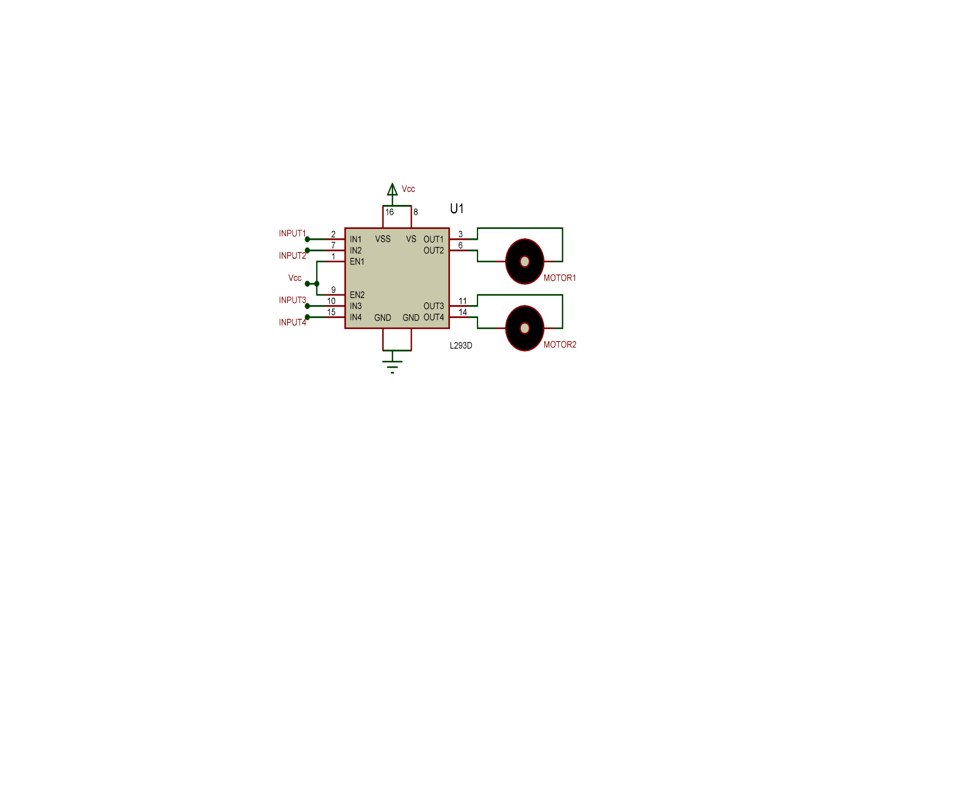

**Figure 2.2.2: Screenshot of DC motor and L293D IC interfacing circuit**

* 1. ***DC Motor***

Almost every mechanical movement that we see around us is accomplished by an electric motor. Electric machines are means of converting conventional energy. Motors take electrical energy and produce mechanical energy. Electric motor is used to power hundreds of devices we use in everyday life. An example of motor used in day to day life is automobiles, food blenders and so is vacuum cleaner.

* 1. ***Bluetooth (HC - 06)***

For the communication of the robot with the cell phone or a mobile we are using the Bluetooth device. The Bluetooth device (HC-06) is attached to the robot that receives the data from the mobile and also it can transmit the data. It is used for converting serial port to Bluetooth. It has two modes: Master and Slave. Bluetooth is a wireless communicationprotocol running at the speed of 2.4 GHz with the architecture of client-server and which is suitable for forming personal area networks. It is designed for devices such as mobile phones (low power). Bluetooth protocol uses the MAC address of the device. Bluetooth gives the connectivity between two devices using their MAC address.

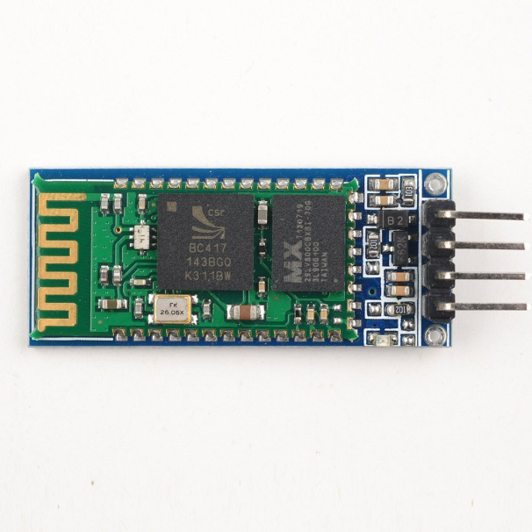

**Figure 2.4: Bluetooth Module**

* 1. ***IR Sensor***

The sensor consists of two eyes. One eye sends the infrared light and the other eye sees the reflection of that infrared light and measures the distance which is then sent to the Arduino through analog input to perform further operations based on the distance. There are three wires coming from the sensor.i.e.Red,Black and White or it can be Red,Brown and Yellow. Red is connected to 5V of arduino. Black or brown to Ground of arduino. White or yellow to analog input pin of arduino i.e. in this case to analog pin 0.

* 1. ***LDR Sensor***

The light dependant resistor is an electronic component whose resistance decreases with increasing light intensity.It is also called as “Photo Resistor” or “Photo conductor”. The light dependant resistor uses high resistance semiconductor material. When light falls on such a semiconductor the bound electrons [ ie., Valence electrons] get the light energy from the incident photos. Due to this additional energy, these electrons become free and jump in to the conduction band. The electron –hole pairs are generated. Due to these charge carriers, the conductivity of the device increases, decreasing its resistivity.

* 1. ***Ultrasonic Sensor***

This sensor is a high performance ultrasonic range finder. It is compact and measures an amazingly wide range from 2cm to 4m. This ranger is a perfect for any robotic application, or any other projects requiring accurate ranging information. This sensor can be connected directly to the digital I/O lines of your microcontroller and distance can be measured in time required for travelling of sound signal using simple formula as below. Distance = (Echo pulse width high time * Sound Velocity (340M/S)/2) or Distance in cm = (Echo pulse width high time (in uS)*0.017) The module works on 5VDC input and also gives an output signal directly for detection of any obstacle up to 4M.Power up the sensor by 5VDC using pins “VCC” and “GND”. First of all a 10us trigger input has to be given to the pin named “Trig” on the sensor. This starts one cycle of range conversion and sends 8 bursts of sound waves from the transmitter. As soon as the signals are transmitted the “Echo” pin goes to high level and remains in high level until the same sound waves are received by the receiver. If the received sound waves are same as what the same sensor transmitted then the Echo pin goes to low level. If no object is detected within 5M after 30ms the Echo signal will automatically go to low level.

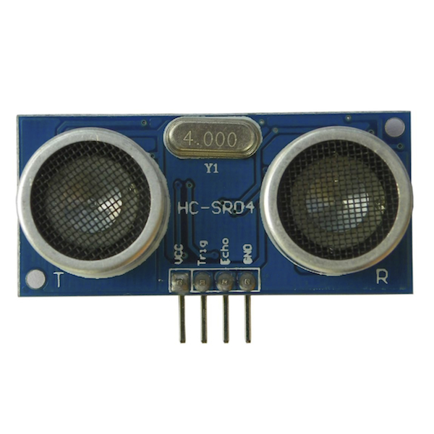

**Figure 2.7: Ultrasonic Module**

* 1. ***Real Time Clock***

A **real-time clock** (**RTC**) is a computer clock (most often in the form of an integrated circuit) that keeps track of the current time. Although the term often refers to the devices in personal computers, servers and embedded systems, RTCs are present in almost any electronic device which needs to keep accurate time.

Although keeping time can be done without an RTC, using one has benefits:

* Low power consumption (important when running from alternate power)
* Frees the main system for time-critical tasks
* Sometimes more accurate than other methods
  1. ***LCD 20X4 Module***

A liquidcrystal display (LCD) is a flat panel display, electronic visual display, or video display that uses the light modulating properties of liquid crystals. Liquid crystals do not emit light directly. 20x4 means that 20 characters can be displayed in each of the 4 rows of the 20x4 LCD, thus a total of 80 characters can be displayed at any instance of time.

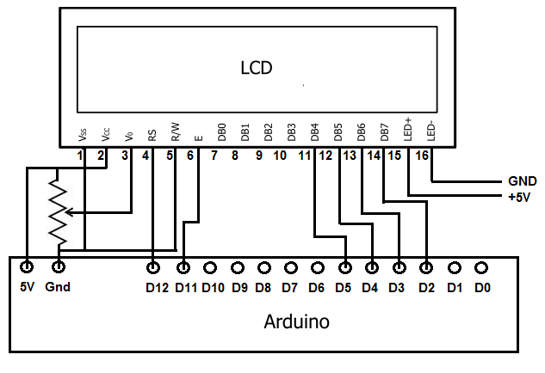

**Figure 2.9: LCD Module**

**Ch-3 Application Software**

The Android app is generally developed using JAVA language. The app controlling this vacuum robot can be built without having the knowledge in java language. It is called as “VBot211” developed by MIT App Inventor. Shown below is a diagram which shows the interface of the app. The app shown below has 5 buttons and all the button gives 5 different bytes in the output that is to be fed to the microcontroller to further process. For e.g. if we press Up! Button, the Bluetooth module will give 1 byte at its output.

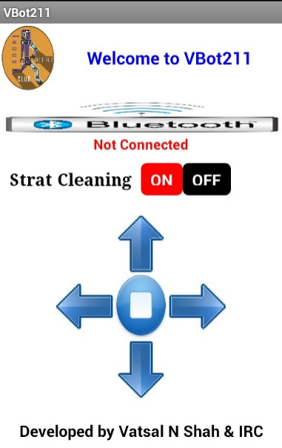

**Figure 3.1: Application Display 1**

The app invented by these searches for the Bluetooth devices along with their MAC addresses. The user just needs to select a particular MAC Address. When a particular MAC is selected, the status shown on the screen is “Connected”. Now all the buttons are active and the app is now connected with the robot and mobile phone can control the robot, like shown below.

**Ch-4 Result and Analysis**

The aim of this project is to design and develop a Autonomous and Android Application based Vaccum Cleaning Robot.

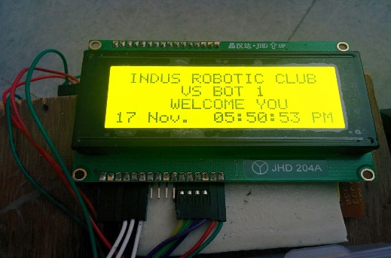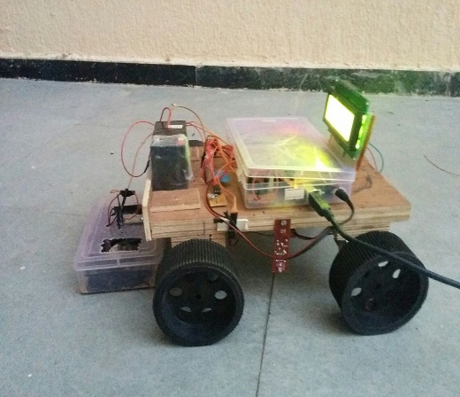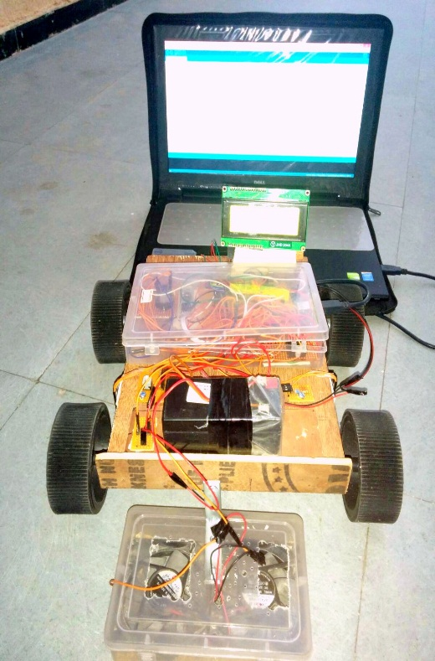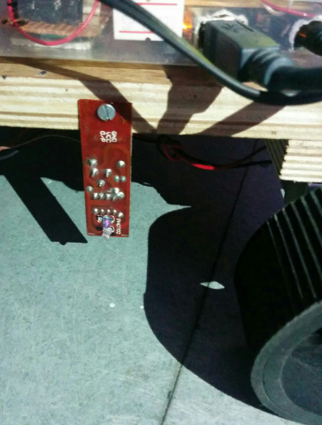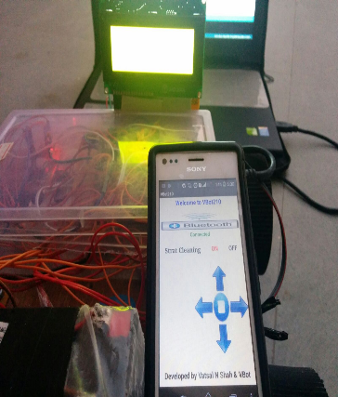

**Figure 4.1:Full Development System.**

**Table 4.1: Operation of components in different modes**

|  |  |  |
| --- | --- | --- |
| **Components↓ Modes→** | **Autonomous mode** | **Manual mode** |
| LCD |  |  |
| RTC |  |  |
| LDR |  |  |
| LED |  |  |
| Switch |  |  |
| Motors |  |  |
| IR Sensors |  |  |
| Ultrasonic |  |  |
| Bluethooth |  |  |

**Ch-5 Conclusion**

**Conclusion:**

A cheaper and user friendly Vaccum Cleaner robot can be developed with two different mode of controlling (Manual and Autonomous mode) using an Arduino.

# **References**

1. L293D datasheet. Website (www.ti.com)
2. S.Muruganandhan, G.Jayabaskaran, P.Bharathi, “LabVIEW-NI ELVIS II based Speed Control of DC Motor,” International Journal of Engineering Trends and Technology (IJETT) Volume 4 Issue 4, April 2013
3. A Technical Analysis of Autonomous Floor Cleaning Robots Based on US Granted Patents, European International Journal of Science and Technology Vol. 2 No. 7 September 2013. Liu, Kuotsan1, Wang, Chulun
4. <http://web.stevens.edu/ses/me/fileadmin/me/senior_design/2007/group01/DesignFinal.pdf>
5. <http://eng.najah.edu/sites/eng.najah.edu/files/robotic_vacuum_pre_1.pptx>
6. <http://www.ecs.umass.edu/ece/sdp/sdp05/preston/sdp_data/Draft%20System%20Specification.doc>
7. <http://letsmakerobots.com/node/40288>
8. <http://www.intorobotics.com/build-diy-roomba-style-robot-vacuum-cleaner/>
9. <http://www.irobot.com/For-the-Home/Vacuum-Cleaning/Roomba.aspx>
10. <http://eprints2.utem.edu.my/4710/1/Design_And_Implementation_Of_Vacuum_Robot_-_24_pages.pdf>
11. <http://www.instructables.com/id/Floor-vacuum-cleaner-robot-controlled-by-Arduino-w/>
12. <http://www.scribd.com/doc/231094704/Automatic-vacuum-cleaner-project#scribd>